RESOURCES
To learn more about the history and requirements of the Clery Act visit safety.colostate.edu/annual-safety-reports-clery-act/
To learn more about Title IX requirements and resources please visit supportandsafety.colostate.edu
CSA DEFINITION
A Campus Security Authority (CSA) is a specific university employee, student, and/or contractor that is federally mandated under the Clery Act with the responsibility to report crimes that are reported to them. If you have been identified as a CSA your role at CSU falls under one of the following four categories:
- You are a member of the CSU Police Department.
- You are not a member of the CSU Police Department but are responsible for campus security.
- You have been designated by CSU as someone to whom crimes should be reported. (e.g., Title IX Coordinator)
- You are someone with significant responsibility for student and campus activities. (e.g., a director who oversees housing; an athletic director; a faculty advisor to a student group or club)
CSA RESPONSIBILITIES
Immediately dial 911 in the event of an emergency.
CSAs are obligated to report any Clery reportable crimes that occur within Clery geography. You can report in person at Green Hall or by filling out the Clery Crime Report Form located at safety.colostate.edu/annual-safety-reports-clery-act/.
Keep in mind:
- You are NOT required or expected to investigate.
- You are NOT a confidential resource but you can direct others to confidential services such as the Counseling Center.
- You are encouraged to assist the victim in reporting.
  - A victim can choose not to report, however a CSA is still obligated to report.
- Reports should be made as soon as possible. We have a responsibility to notify our campus community within a reasonable time frame about any situation that may impact health and safety.
CLERY CRIMES
The crimes listed below are the crimes that are required to be reported by the Clery Act. If you have any questions regarding a crime, location, or reporting requirements contact Josh McClure at the CSUPD. When in doubt, report.
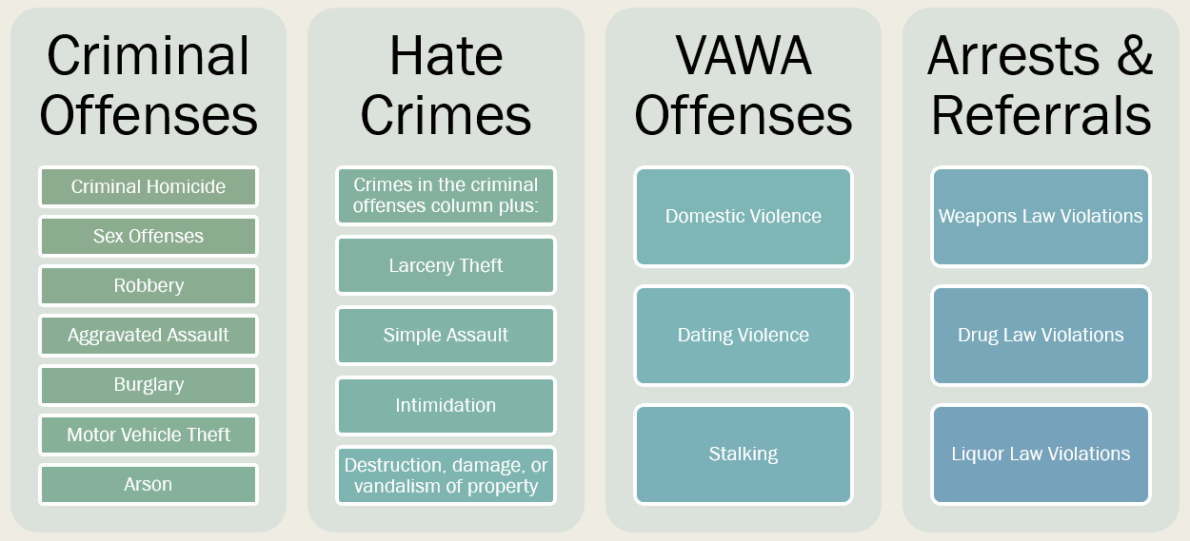

CLERY GEOGRAPHY
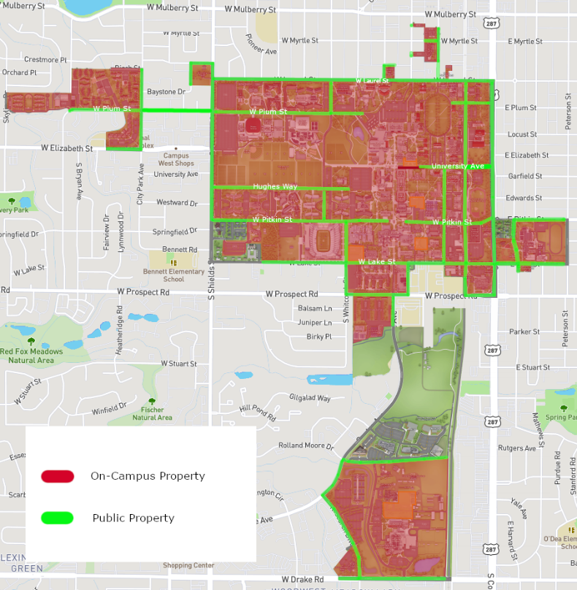
CSU Clery geography:
- On-Campus Property
- Main and South Campus
- Reasonably contiguous extended locations (HSBC, UV, IH)
- All residence halls and CSU owned apartments
- Non-Campus Property
- CSU Mountain Campus
- West Campus
- All out of city/state properties
- Hughes Stadium property
- Northern Hotel
- Public Property
- Thoroughfares, streets, and sidewalks, within or immediately adjacent to and accessible from campus.

TITLE IX AND THE CLERY ACT
Title IX and the Clery Act are two separate federal laws that both address sexual violence. Below is a chart to clarify the differences and reporting requirements of these laws.
 | Title IX | Clery Act
Titles | All CSU employees and volunteers, including faculty, staff, and students acting in their employment or volunteer roles are Responsible Employees, meaning they are mandatory reporters of any violations or alleged violations of Title IX. Responsible Employees are required to make those reports to the Office of Support and Safety Assessment within 24 hours of knowledge of incident. Those exempt only include licensed healthcare professionals and victim advocates. | Only Individuals who meet the federal definition are Campus Security Authorities.
Overview | Title IX is concerned with any incident of sex-based discrimination that occurs whether it involves a student, faculty, staff member, or guest of CSU. If the incident is made known by a Responsible Employee, it is required to be reported regardless of when or where the incident occurred. Resources are available for any party. | Clery is concerned with where and what crime occurred.  If a Clery crime occurs within Clery Geography, it should be reported whether or not the victim/perpetrator is affiliated with the university.
Intersections | Both Title IX and the Clery Act address sexual offenses. While many of the processes to resolve sexual offenses are the same, there are different reporting processes.
Reporting | Any incident of sexual violence occurring on or off campus should be reported directly to the Office of Support and Safety Assessment at (970) 491 – 1350. | Sexual offenses that occur on-campus should be reported to CSUPD. CSUPD works closely with Title IX.

QUESTIONS?
If you have any additional questions, please contact the Director of Clery Compliance Programs
vpuo_clery_compliance@mail.colostate.edu

